**Problem Definition and Design Thinking**

The scope of this document is to identify the problem and find solution for Traffic management to receive real time Environmental Data.

**Problem Definition:**

It has been researched and found that there has been the following issues with public traffic management. The issues or problems are listed below:

* Public traffic management faces several challenges, including traffic congestion, inefficient infrastructure, and a lack of public transportation options.
* Traffic congestion results in longer travel times, frustration, and environmental pollution.
* Occurrence of traffic accidents poses a grave threat to public safety.
* Many road systems suffer from poor traffic flow, leading to delays and transportation inefficiencies.

**Design Thinking:**

Having understood the above problem. We would designing a solution which would be able to solve the same.

* An IoT based solution could immediately resolve the above issue.
* Collecting date, such as traffic flow, vehicle speeds, and weather conditions.
* Creating a central control system capable of receiving and processing data from sensors with intelligent decision-making logic to respond to real-time traffic conditions.
* Implementing the security measures to protect data and address privacy concerns, ensuring compliance with local regulations and data privacy standards.
* Hence we would need internet connectivity and real time monitoring.

**INNOVATION OF TRAFFIC MANAGEMENT SYSTEM**

**Our traffic management plan shall address the following:**

1.Hours of Work

2.Duration of Works

3.Project Details

4.TrafficManagement System

5.TrafficManagement

6.Layout/Drawing

7.Phasing of Works

8.TrafficManagement Signage

9.Speed Limits

10.Road Level

11.DesignParameter

12.Site Access & Egress

13.Communication and Emergency Procedure

**Some methods of traffic control are:**

* Two-Way Traffic
* Give & Take
* Priority
* Stop & Go
* Temporary Traffic Signals
* All Stop & Convoy
* Road Closure
* Lane Closures
* Semi-Static Operation
* Mobile Lane Closure

**Our Traffic management plan may include details of:**

* The desired flow of pedestrian and vehicle movements
* The expected frequency of interaction of vehicles and pedestrian
* Illustrations of the layout of barriers, walkways, signs and general arrangements to Warn and guide traffic around, past, or through a work site or temporary hazard
* How short term, mobile work and complex traffic situations will be managed

**Our traffic management plan could also set out:**

* Responsibilities of people managing traffic in the workplace
* Responsibilities of people expected to interact with traffic in the workplace, and instructions or procedures for controlling traffic including in an emergency.

**WAYS TO CONTROL TRAFFIC RISKS:**

* Barriers or guardrails at building entrances and exits to stop pedestrians walking in front of vehicles.
* High impact traffic control barriers
* Temporary physical barriers
* Separate, clearly marked footpaths or walkways e.g. using lines painted on the Ground or different coloured surfacing .

**General components of our traffic management system:**

Data collection : That’s the part where hardware devices like sensors, cameras, GPS trackers, etc., are called into action. …

Data transmission. …

Data analysis. ..

Data conversion into intelligent information. …

Data transmission to end-user.

**Hardware Requirement:**

* Internet Connection
* GB/2GB RAM
* 8 GB Disk
* Above 1.2 GHz Processor
* Camera
* Ultrasonic Sensor

**Software Requirement:**

OS – Windows

Language – python

* We use wokwi and Thinkspeaks web server.
* Our innovation to perform is Vehicle to Vehicle Communication.

**Traffic Management**

A Traffic Management IoT project involves the use of Internet of Things (IoT) technology to improve the efficiency, safety, and sustainability of traffic and transportation systems. Such projects can have a wide range of applications, from monitoring and controlling traffic flow to providing real-time information to drivers and city planners.

When a vehicle approaches an intersection or a busy road section, the nearby LCD display continuously updates drivers on the traffic status. If the road is congested, it advises drivers to take alternative routes or reduce their speed.

The system monitors traffic flow and can prioritize specific lanes or routes based on the data collected from the vehicle detection sensors. For example, during rush hours, the system may allocate more green light time to the main traffic direction.

In the event of an accident or roadwork, the system can display detour information on the variable message signs, guiding drivers to choose alternative routes to avoid delays.

If a road section becomes too congested, the system can also alert traffic management authorities to take action, such as deploying additional traffic control personnel or sending emergency services.

**Block Diagram of Traffic Management Project**

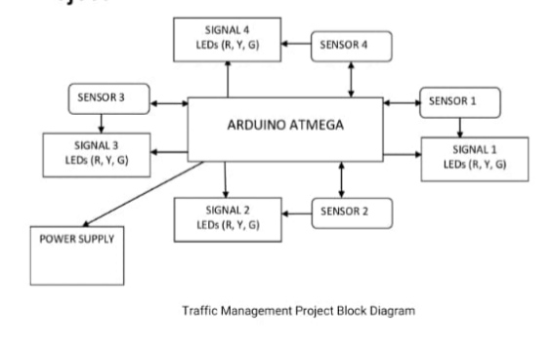

**Components Required**

|  |  |  |
| --- | --- | --- |
| **S. No** | **Components** | **Quantity** |
| **1.** | **Arduino or Microcontroller** | **1** |
| **2.** | **PIR Sensor** | **4** |
| **3.** | **Ultrasonic Sensor** | **2** |
| **4.** | **Service Motor** | **2** |
| **5.** | **Traffic Lights** | **4** |
| **6.** | **Communication Modules (e.g.., Wi-Fi, GSM)** | **1** |
| **7.** | **LCD Display** | **1** |
| **8.** | **15v Power Supply** | **1** |
| **9.** | **Cables and Connectors** | **As Needed** |

**Tool Required**

|  |  |  |
| --- | --- | --- |
| **S. No** | **Tools** | **Example** |
| **1.** | **Arduino IDE** | **Ardunio IDE** |
| **2.** | **CAD Software (optional)** | **Autodesk Eagle** |
| **3.** | **Version Control System** | **GitHub, GitHub Desktop** |
| **4.** | **Project Management Software** | **Thinkspeak** |
| **5.** | **Simulation Software (optional)** | **Wokwi** |
| **6.** | **Data Analysis Tool** | **Excel** |
| **7.** | **Communication Tools** | **Microsoft Teams, Discord, Zoom** |

**Testing and Safety Equipment:**

**Safety Gear:** As needed – Safety glasses, gloves, and other personal protective equipment.

**Test Vehicles:** As needed – For testing traffic flow and response under controlled conditions.

**Traffic Cones and Barriers:** As needed – For creating controlled test environments.

**Traffic Signs and Road Markings:** As needed – For creating realistic traffic scenarios during testing.

**Circuit Diagram of Traffic Management Project using Arduino, IR Sensor and UltraSonic Sensor.**

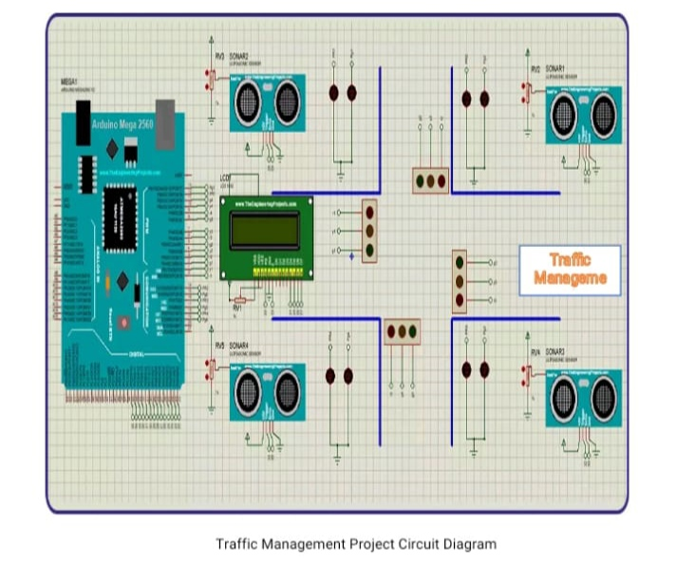**Working Principle:**

After assembling all components according to the circuit diagram and uploading the code to the Arduino board. Now place the sensors and servo motor at accurate positions.

The IR sensors detect vehicles at intersections and entry/exit points, while ultrasonic sensors measure distances to objects. Arduino collects this data.

Arduino processes the sensor data to monitor traffic conditions, identifying congestion or obstacles. It analyzes the data in real-time.

Based on the analysis, Arduino adjusts traffic signals, variable message signs, or gate control using servo motors to optimize traffic flow.

LED displays and alerts provide real-time feedback to drivers, guiding them and enhancing road safety.

In case of accidents or emergencies, the system can send alerts to traffic management authorities or emergency services for swift action.

The project's working principle centers on data collection, analysis, and control to improve traffic flow and safety, with Arduino acting as the central controller.